Chapter 7, Problem 18.

For the circuit in Fig. 7.98, determine v_{o}(t) when i(0) = 5 A and v(t) = 0.

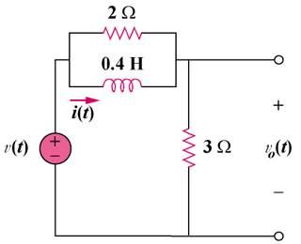

Figure 7.98
For Prob. 7.18.

